PLEASE PRINT CLEARLY
5 – A – SIDE FOOTBALL TOURNAMENT
SUNDAY 17TH JUNE 2018
11.00 – 3.30pm
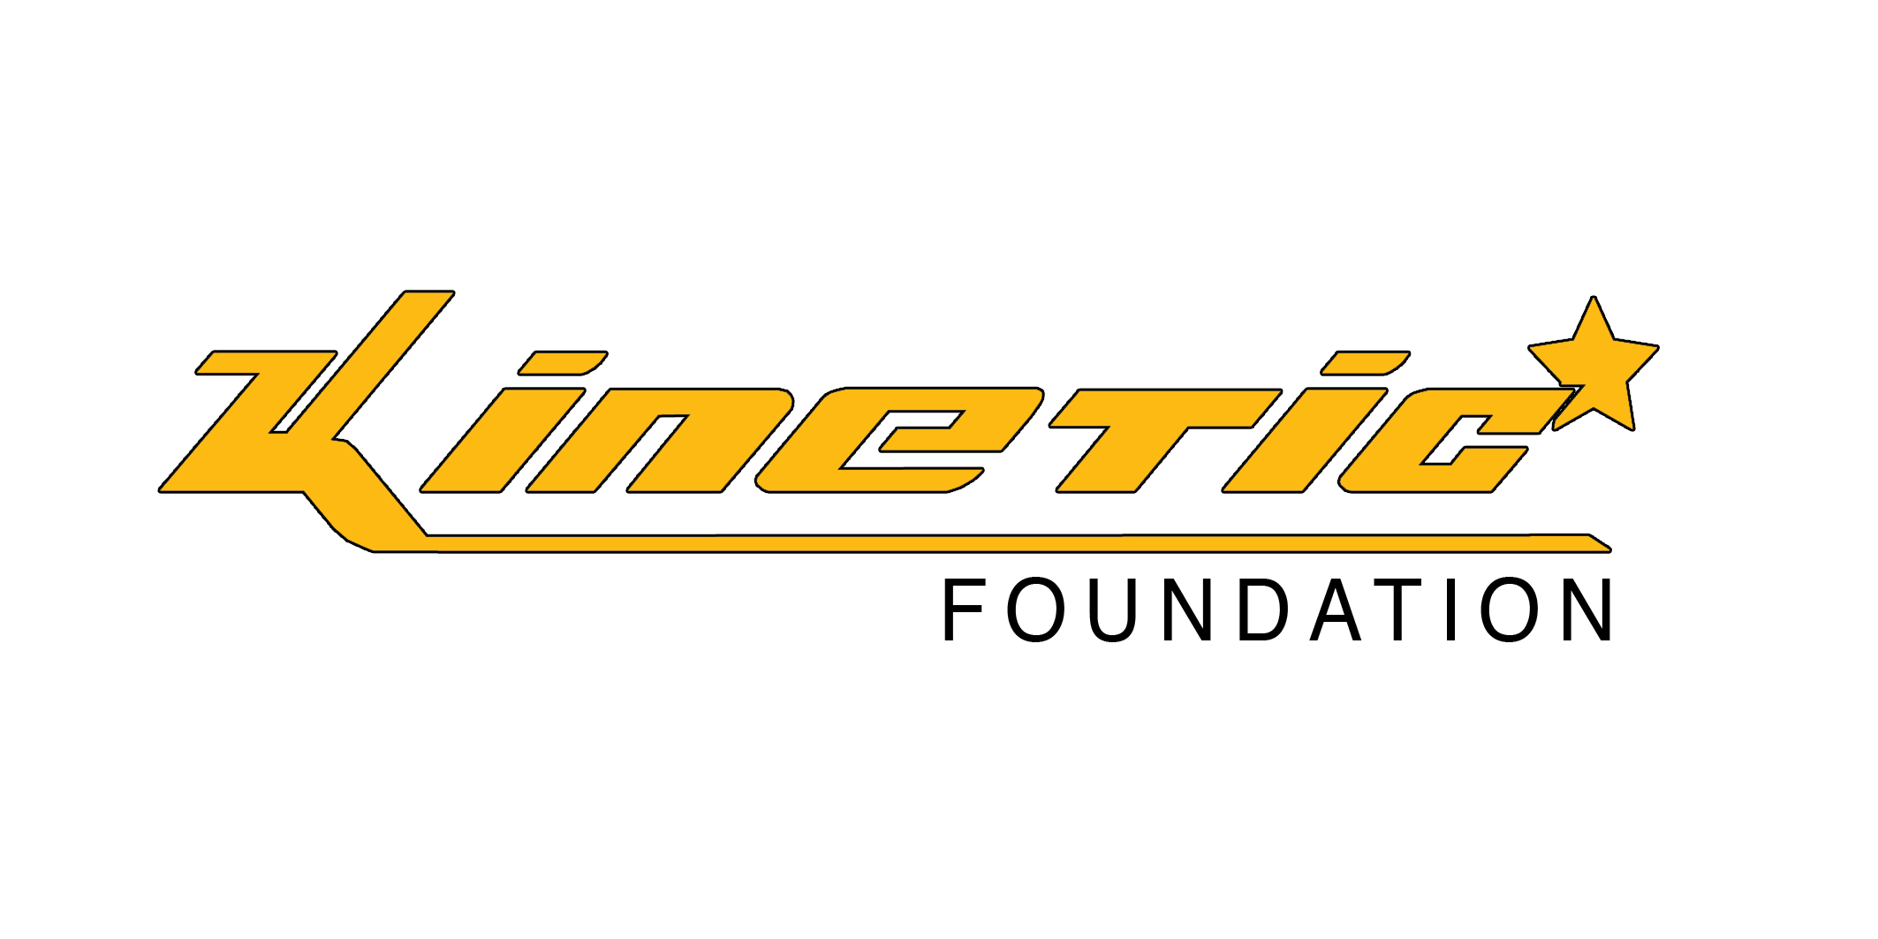
PLEASE PRINT CLEARLY – Closing date for Entry 14th June 2017
TEAM NAME:
AGE GROUP: please circle | YEAR1/2 YEAR 3/4 YEAR 5/6
TEAM MANAGER: | Each team must have a responsible adult (over 18years)
NAME:
ADDRESS:

TELEPHONE NUMBER:
MOBILE NUMBER(on the day):
E MAIL ADDRESS:
MANAGERS SIGNATURE:

TEAM: | MAXIMUM 7 PLAYERS ( no club teams please) | DATE OF BIRTH | SCHOOL
1.
2.
3.
4.
5.
6.
7.
Players must wear trainers, astro boots or moulded boots (no metal studs) - shin pads essential.
Please send the completed booking form to:
Kinetic Foundation, Unit 39, 56-58 Factory Lane Croydon CR0 3RL
together with a receipt for £50 BACS transfer to Acc no: 41729868 sort code: 30-84-51
(use team name as your reference).
The registration fee is non-refundable, even if a team is unable to participate for whatever reason. Teams may play with fewer than 5 players.
Changes can be emailed to info@kinetic-foundation.org.uk until end of day 15th June 2017 or provided to the team registration desk on the day. No entries will be accepted after this date
At least one responsible adult must accompany the team to each match. Kinetic Foundation may wish to take photographs for use in their publicity. Please let us know if any member of your team members would not consent to this.
For all queries please e mail: info@kinetic-foundation.org.uk or phone Kinetic office on 020 3581 3745

